BARLOWS PRIMARY SCHOOL
Escalation Policy

Committee with oversight for this policy | Full Governing Body
Policy to be approved by the Full Governing Body | 11th November 2019
Policy last reviewed by the Full Governing Body
Policy last ratified and adopted by Full Governing Body
Policy / Document due for review | Autumn 2020

Barlows Primary School Escalation Policy
Log of amendments
Page | Amendment made | Date
Whole Document | Updated and LSCB’s LSCB Resolution & Escalation Procedure added as an appendix | 12th September 2019

Barlows Primary School Escalation Policy
Contents Page
Page 1: | Escalation Policy title page
Page 2: | Escalation Policy table of amendments
Page 3: | Escalation Policy contents page
Page 4: | What is escalation?
Page 4: | In school escalation
Page 4: | Professional Agency Escalation
Page 6: | LSCB* Resolution & Escalation Procedure (Appendix A)
Page 9: | Resolving Professional Disagreements Process and Timescales  9
Page 10: | LSCB Resolution & Escalation Procedure – Supporting Notes
Page 11: | Appendix 1: Agency Escalation Log
Page 12: | 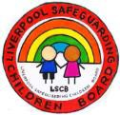  Appendix 2. Report to LSCB: Multi Agency Resolution: Escalation Stages 3 and 4
Page 13: | LSCB Resolution & Escalation: Agency Representation
* Resolution and Escalation Procedure accessed from Liverpool Safeguarding Children Partnership website. Document still refers to Liverpool Safeguarding Children’s Board (LSCB)
Barlows Primary School Escalation Policy

Barlows Primary School promotes to all staff and volunteers that, safeguarding is everybody’s responsibility. This policy provides guidance to all adults working within the school whether paid or voluntary or directly employed by the school or by a third party. The policy should be read in conjunction with Liverpool’s Children’s Safeguarding Partnership* (LSCP) Resolution and Escalation procedure of Resolving Inter Agency Professional Disagreement (Appendix A), to ensure that “Effective Escalation Supports Effective Safeguarding.”
* Still referred to and Liverpool Safeguarding Children’s Board (LSCB) on procedure document.
What is Escalation?
Escalation is a process of formally challenging a decision made by another professional, group or organisation. Escalation procedures ensure that all professionals have a quick and straightforward means of resolving professional differences in order to safeguard the welfare of children and young people.
Escalation is not a negative action or criticism.
In School Escalation:

If any member of staff is unhappy with the response they have received in relation to a safeguarding
concern they have raised with the school safeguarding team, it is their responsibility to ensure they escalate their concern. All members of staff have the responsibility to escalate and refer concerns on to Children’s Services when it is appropriate to do so.

Professional Agency Escalation:

Where professional disagreement occurs with agencies and the Designated Safeguarding Lead and / or Deputy are unhappy with the actions or decisions of another agency, they will escalate their concern in line with the Local Safeguarding Children Partnership’s formal escalation policy to ensure a timely resolution.

The first step of any escalation process with another agency, is to raise any concerns directly with the
other professional and their line manager. Barlows Primary School recognises that a professionals’ meeting is always a positive way of resolving differences and remaining focussed on the outcomes for the child.

Safeguarding is everyone’s responsibility and school staff and agency professionals need to have confidence in talking with each other about decisions that have been made, discussing any concerns regarding those decisions and where there isn’t agreement and escalating those concerns as appropriate to seek resolution.
Staff need to maintain their professionalism and remember it is equally important to consider the culture of how they work; and it is vital that front-line staff are encouraged to remain professionally curious and to raise issues where they feel that their concerns for children and young people aren’t being addressed.
Effective working together depends on an open approach and honest relationships between the school and agencies. Problem resolution is an integral part of professional co-operation and joint working to safeguard children.
Disagreements can arise in a number of areas, but are most likely to arise around:
- levels of need
- roles and responsibilities
- the need for action
- progressing plans and communication.
Where professionals consider that the practice of other professionals is placing children at risk of harm, they must be assertive, act swiftly and ensure that they challenge the relevant professionals in line with the guidance set out in the LSCP Resolution and Escalation Procedure.
Staff should always remember:
- The safety of individual children is the paramount consideration in any professional activity.
- Resolution should be sought within the shortest timescale possible to ensure the child is protected.
- Disagreements should be resolved at the lowest possible stage.
The safety and wellbeing of individual children and young people is the paramount consideration in any effective challenge and escalation.

Appendix A

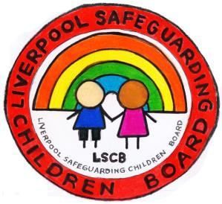
Liverpool
Safeguarding
Children
Board

LSCB Resolution & Escalation Procedure

Resolving Inter-Agency Professional Disagreement

‘Effective Escalation Supports Effective Safeguarding’

LSCB Resolution & Escalation Procedure

‘Risks to children are increased when inter-agency dispute resolution and escalation processes are weak and ineffective’
LSCB Practice Learning Review (Jan 2018)

‘Escalation is…. an effective mechanism for resolving professional disagreement.’ Escalation is not…. a negative action or criticism.

Resolution
When working with children and their families professional disagreement can be positive, as challenge allows for review and can foster creative ways of working, however, disagreements can impact negatively on positive working relationships and consequently on the ability to safeguard and promote the welfare of children. Disagreements always require resolution.

What is Escalation?
Escalation is a process of formally challenging a decision made by another professional, group or organisation. Escalation procedures ensure that all professionals have a quick and straightforward means of resolving professional differences in order to safeguard the welfare of children and young people.

Escalation - Principles
Effective working together depends on an open approach, clarity of roles and responsibilities and genuine, and honest, relationships between agencies. Escalation is a means of resolving professional differences and is an integral part of joint working to safeguard children.

Liverpool Safeguarding Children Board (LSCB) encourages effective challenge to support effective safeguarding. All agencies across the partnership have agreed to work in a culture of genuine partnership working and have committed to the following principles;

The safety and wellbeing of individual children and young people is the paramount consideration in any effective challenge and escalation.
- Effective challenge is a positive action.
- Practitioners should take responsibility for their own cases and actions;
- Any disagreements between agencies should be resolved as simply and quickly as possible;
- Practitioners should respect the views of others, whatever their level of experience, the role they fulfil or agency they represent.
- Practitioners and managers should always be prepared to review decisions and plans with an open mind;
- Working together effectively depends on resolving disagreements to the satisfaction of workers and agencies, with a genuine commitment to partnership working

Differing opinions could arise in a number of areas, but are most likely to arise when considering:

- levels of need and intervention,
- lack of understanding of roles and responsibilities,
- the need for action and communication.

Examples, where the concerns about the child should prompt action, are given below. This is list is not exhaustive.

- Dispute at the point of referral due to differing opinions about thresholds.
- Concern about the action / inaction of another professional in relation to a child or family member.
- Disagreement about decision making and a course of action to be taken, for example whether there should be a Child Protection Case Conference or, whether a case should be closed.
- Dissent at / arising from a Child Protection Case Conference. Dissent arising from the implementation of a CP Plan.
- Disagreement over information sharing.
- Disagreement over an assessment and differences around professional analysis and joint decision making.
- Disagreement over the provision of services.
- Concern there is drift or unreasonable delay in a case.
- Concerned about the operation of child protection procedures.

WHEN ANY PROFESSIONAL CONSIDERS A CHILD IS AT IMMEDIATE RISK OF SIGNIFICANT HARM, THEN THE INDIVIDUAL MUST ENSURE THEIR CONCERNS ARE ESCALATED ON THE SAME WORKING DAY USING ESTABLISHED SAFEGUARDING PROCEDURES.

Where professionals consider that the practice, or the decision making of other professionals is placing children at risk of harm, they must be assertive act swiftly and ensure that they challenge any relevant professionals in line with this policy.

- The safety of individual children is the paramount consideration in any professional activity.

- Resolution should be sought within the shortest timescale possible to ensure the child is protected.

This procedure is not designed to replace complaint processes established within individual partner agencies.

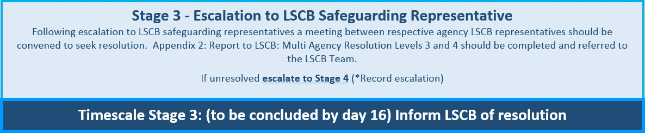
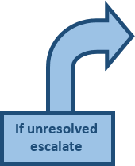
Resolving Professional Disagreements Process and Timescales
9
Professional disagreement should be resolved at the lowest possible stage within the shortest possible timescale
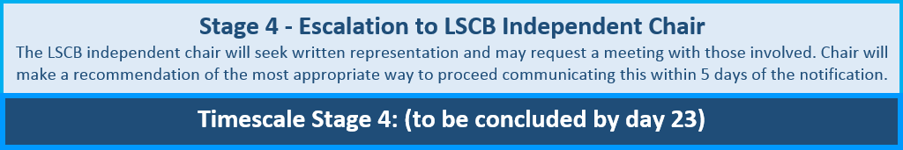
At each stage record agreed outcome or matters unresolved

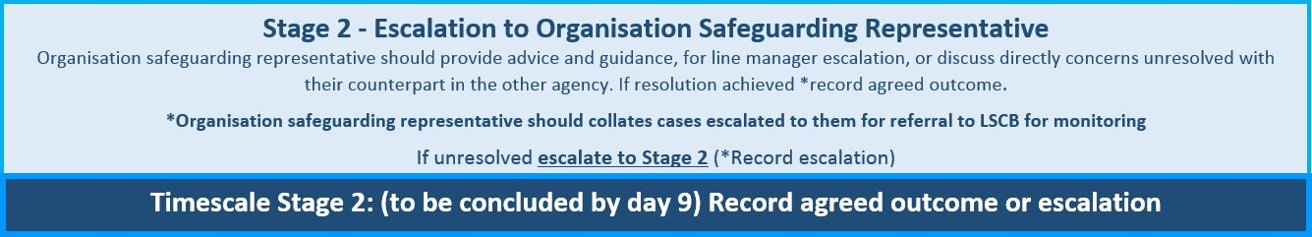
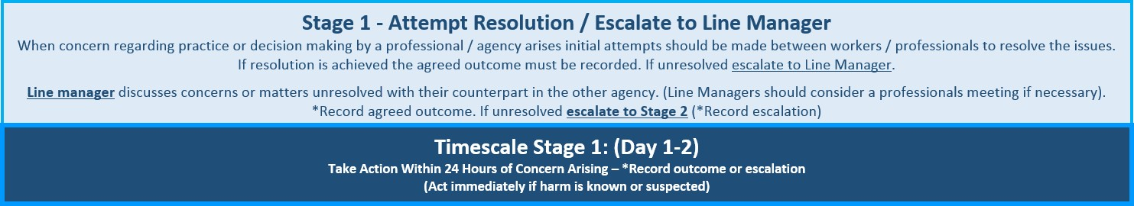

LSCB Resolution & Escalation Procedure – Supporting Notes
RECORD: Where professionals escalate a matter of concern, internally to a line manager or externally to a safeguarding representative, details of matters escalated must always be recorded on a child or young person’s case records.

Stage 1. Attempt Resolution.
Most disagreements can be resolved between professionals by having a conversation about the reasons for the difference of opinions and without having to escalate the matter further. Initial attempts should be made between workers to resolve the issues through discussion. This discussion must take place as soon as is possible. This can be a telephone conversation or face to face meeting. The agreed outcome of discussions or actions must be recorded using the *Escalation Summary Log (*See Appendix 1) and on the child’s case file. If matters remain unresolved this also must be recorded on the Escalation Summary Log and escalated to a Line Manager.

Escalate to Line Manager.
Where matters are escalated to a line manager concerns, or matters unresolved, should be discussed with their counterpart in the other agency. Respective parties must identify explicitly what the problem is and have absolute clarity about the nature of the professional challenge and what the respective workers aim to achieve. Line Managers must always consider convening a professionals meeting if necessary. The outcome of discussions, matters resolved or actions agreed must be recorded. Line managers must complete the *Escalation Summary Log (See Appendix 1) and detail matters agreed on the child’s case file. If matters remain unresolved this must also be recorded and escalated to Stage 2 and the organisation safeguarding representative. (Day 1 -2).
*(Where a child is subject to a Child Protection Plan (CPP) or a Child Looked After (CLA) the Independent Reviewing Officer must also be notified.)

Stage 2. Escalation to Organisation Safeguarding Representative
Where matters are escalated to an organisation safeguarding representative advice or guidance should be given for line manager escalation or the organisation safeguarding representative should discuss concerns, or matters unresolved, with their counterpart in the other agency. The outcome of discussions, matters resolved or actions agreed must be recorded. (To be concluded by Day 9)

*Organisation safeguarding representatives must collate detail of cases escalated to them using the *Escalation Summary Log (See Appendix 1) for referral to the LSCB Team for monitoring.
If matters remain unresolved detail of dispute must be recorded and escalated to Stage 3 and the respective LSCB representative.
NOTE: *Where a safeguarding representative, having appropriately reviewed the LSCB levels of need guidance with children’s services, consider a child to be at immediate risk of significant harm, appropriate escalation to service managers within children’s services can be made. For children not deemed to be at immediate risk of significant harm stage 3 procedures should be followed.
Where matters are escalated to Stage 3: Report to LSCB: Multi-Agency Resolution Levels 3 and 4 (See Appendix 2) must be completed and referred to the LSCB Business Officer, Jacqui.taylor@liverpool.gcsx.gov.uk

Stage 3: Escalation to LSCB Safeguarding Representative.
Respective LSCB safeguarding representatives should endeavour to resolve matters at this stage. (Please contact the LSCB Business Officer for details of your agency’s LSCB representative). If matters remain unresolved a meeting must be convened between the LSCB agency representatives together with a partnership representative who will undertake a mediation role. (The LSCB Business Manager should be contacted to identify the partnership representative.) Where LSCB representatives are unable to resolve matters through this process, the matter must be escalated to the LSCB Independent Chair. (To be concluded by Day 16)

Stage 4: Escalation to LSCB Chair
If it has not been possible to resolve professional differences following review by the LSCB safeguarding representative, matters should be referred by the concerned agency to the independent Chair of the LSCB. The Independent LSCB Chair may seek to resolve issues directly with relevant senior managers or convene a resolution panel. The agency raising the dispute must email detail to the LSCB Business Manager via LSCB Business Officer: Jacqui.taylor@liverpool.gcsx.gov.uk
The LSCB Independent Chair or panel, as necessary, will consider written representations, from those involved in the dispute, and will resolve the professional differences concerned. (To be concluded by day 23)

Appendix 1: *AGENCY ESCALATION SUMMARY LOG
A summary of cases escalated for resolution should be collated and retained by all organisations.

(For completion by Line Manager - Stage 1 / Line Manager & Safeguarding Representative – Stage 2)

Agency / School: (INSERT)

**Agency / School &  Escalation Number | Child Name / DOB / Age | Concern | Level of Need | Summary of Professional Disagreement | Actions Undertaken Towards Resolution | Outcome of Resolution

*LSCB will collate agency summaries for LSCB monitoring purposes. Summaries to be returned as requested to: Jacqui.taylor@liverpool.gcsx.gov.uk
**Agency / School Escalation number is that allocated to identify the case by the agency or school.

Appendix 2. Report to LSCB: Multi-Agency Resolution: Escalation Stages 3 and 4
(*Multi-Agency Conflicts resolved at Stages 3 and 4 must be reported to the LSCB Team)

Name of Child / young Person:
Date of Birth:
Address:

Name and email of Professional Escalating concern:
Role and Agency:
Name(s) of other professionals involved: (Including LSCB Board Members where appropriate)
Role and Agency:

Please indicate level of need: | Early  Help: |  | S17: |  | S47:
Brief details of inter agency disagreement (including agreed outcomes)

Date of discussion/ Meeting re disagreement:
Methodology used to resolve conflict:
Disagreement resolved at: | Level3: | Level 4:
Please indicate lessons learned from this disagreement resolution (e.g. Individual agency review of procedure, requirement for staff training, further understanding of LSCB Levels of Need);

Please identify any further actions taken by your agency following the resolution of this issue:
Actions taken: | By whom: | Date completed:

Form completed by:
Date:

To be completed by LSCB Business Manager:
Date received by LSCB Business Manager: | Date:
Outcome / Issues notified to LSCB Executive Group: | Date:

Completed reports should be referred to the LSCB Team Jacqui.taylor@liverpool.gcsx.gov.uk

LSCB Resolution & Escalation: Agency Representation
LSCB Resolution & Escalation Policy | Action | School | Health | Children’s Services | Merseyside Police
Stage 1 | Attempt resolution | Designated Safeguarding Lead | Front line staff | Front line staff / social worker | Front line staff
 | Escalate to line manager | Designated Safeguarding Lead / Head Teacher | Safeguarding Specialist Practitioner | Team Manager | Detective Sergeant (PVPU)
Stage 2 | Escalate to agency safeguarding representative | Senior School Improvement Officer Safeguarding (SIL) | Named Nurse | Service Manager (Careline / Assessment / Safeguarding Unit / Permanence) | Detective Inspector (PVPU)
Stage 3 | LSCB Representative | LSCB Representative | Designated Nurse | Assistant Director Children’s Services | Detective Chief Inspector / Superintendent
Stage 4  Escalation to LSCB Chair |  | Liverpool Safeguarding Children Board (LSCB) Independent Chair

