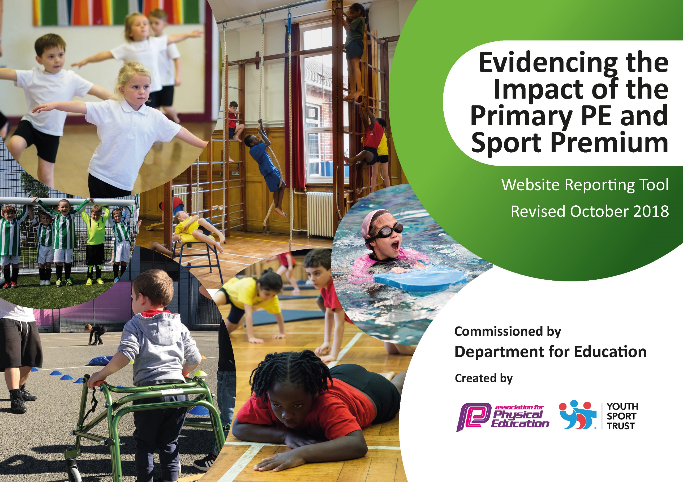
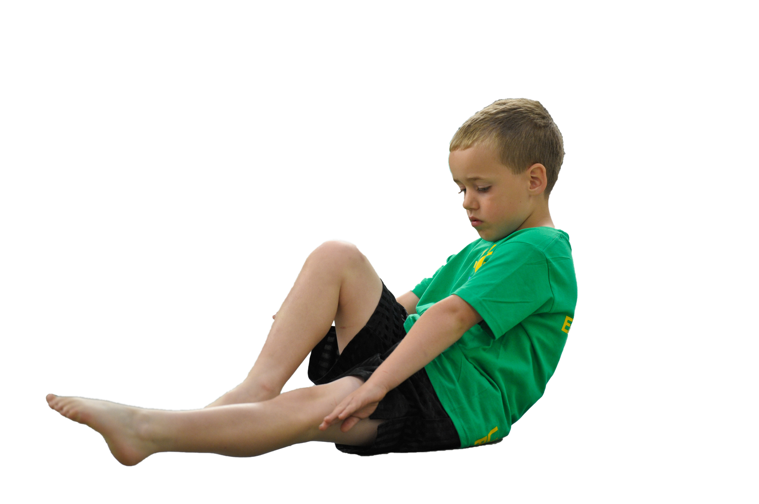
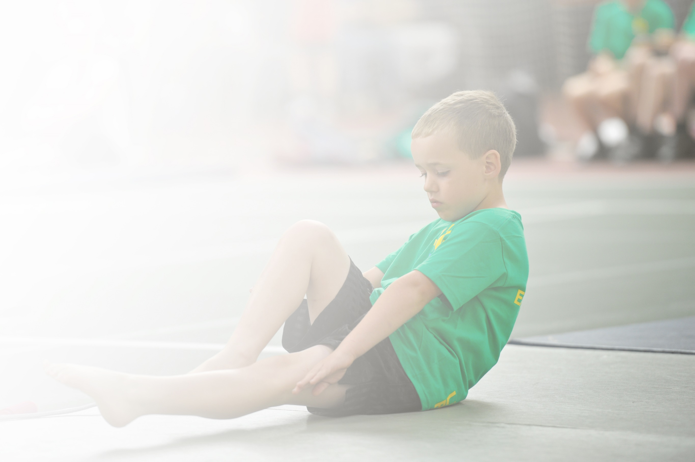
Schools must use the funding to make additional and sustainable improvements to the quality of Physical Education, Sport and Physical Activity (PESPA) they offer. This means that you should use the Primary PE and Sport Premium to:

- Develop or add to the PESPA activities that your school already offer
- Build capacity and capability within the school to ensure that improvements made now will benefit pupils joining the school in future years

Please visit gov.uk for the revised DfE guidance including the 5 key indicators across which schools should demonstrate an improvement. This document will help you to review your provision and to report
your spend. DfE encourages schools to use this template as an effective way of meeting the reporting requirements of the Primary PE and Sport Premium.

We recommend you start by reflecting on the impact of current provision and reviewing the previous
spend. Under the Ofsted Schools Inspection Framework, inspectors will assess how effectively leaders use the Primary PE and Sport Premium and measure its impact on outcomes for pupils, and how effectively governors hold them to account for this.

Schools are required to publish details of how they spend this funding as well as on the impact it has on pupils’ PE and sport participation and attainment by the end of the summer term or by 31 July 2019 at the
latest.
We recommend regularly updating the table and publishing it
on your website throughout the year, as evidence of your
ongoing review into how you are using the money to
secure maximum, sustainable impact. To see an
example of how to complete the table please
click HERE.

Support for review and reflection - considering the 5 key indicators from DfE, what development needs are a priority for your setting and your students now and why? Use the space below to reflect on previous spend, identify current need and priorities for the future.

Key achievements to date: | Areas for further improvement and baseline evidence of need:
- Achieved Silver School Games Mark.  - LSSP Gold membership to ensure specialist coaches deliver high physical education lessons. Each class received a coaching session once a week.  - Coaches working with staff to help CPD in physical education.  - Funding to ensure increased participation in local competitions through LSSP membership.  - Increasing children’s participation in sports and physical activities through break and lunchtime provision.  - Opportunities to compete in Level 2 competition for children on the SEND register (Boccia, New Age Kurling).  - Competitive opportunities (Level 2) offered to children in 12 different sports.  - B teams competed in 3 Level 2 competitions.  - C teams competed in 2 Level 2 competitions.  - All children in Year 6 and 10 from Year 5 involved in leading sporting activity during playtimes.  - Sports coaches from Lancashire CCC, St Helens RLFC, Liverpool Lions RFC have all worked with groups of children this year.  - Girls’ football team qualified for league finals.  - Further links with local high schools by taking part in competitions, festivals on offer (St John Bosco) | - Gymnastics specialist support needed to target specific area of improvement for both children and staff (CPD)  - Develop children’s basic skills (ABCs) through specialist coaching in gymnastics and yoga.  - Target children who do not access competitive sport (eg. Yoga)  - Improve opportunities for children to compete in a wider range of sports (enter cross country league).  - Investigate ways of encouraging children to be more active (eg. Active wristbands?)  - Continue to update and replenish outdoor PE equipment to encourage children to be active during break and lunchtimes.  - Continue to update and replenish PE equipment to ensure high quality provision of physical activity.  - Enhanced inclusive extra curriculum provision (target SEND children, PP, links with CU).  - Widen the opportunity for children to sample a wide range of sporting opportunities through outdoor and adventure activities.  - To improve the mental health of our children through promoting physical exercise and mindfulness (Yoga).  - Address time lost during PE curriculum (PE Kits, children to attend in kit on PE day to ensure prompt start to lessons). This could increase effective learning time by approximately 25%.  - Improve swimming percentages through utilising PESSP Funding to access top up swimming.  - Utilise sports coaches to support high quality provision during lunchtimes.

Meeting national curriculum requirements for swimming and water safety | Please complete all of the below:
What percentage of your current Year 6 cohort swim competently, confidently and proficiently over a distance of at least 25 metres?  N.B. Even though your children may swim in another year please report on their attainment on leaving  primary school. | 72%
What percentage of your current Year 6 cohort use a range of strokes effectively [for example, front crawl, backstroke and breaststroke]? | 65%
What percentage of your current Year 6 cohort perform safe self-rescue in different water-based situations? | 100%
Schools can choose to use the Primary PE and Sport Premium to provide additional provision for swimming but this must be for activity over and above the national curriculum requirements. Have you used it in this way? | Yes/No

Action Plan and Budget Tracking
Capture your intended annual spend against the 5 key indicators. Clarify the success criteria and evidence of impact that you intend to measure to evaluate for students today and for the future.

Key Indicator Reference | Key Indicator
KI 1 | The engagement of all pupils in regular physical activity – Chief Medical Officer guidelines recommend that primary school children undertake at least 30 minutes of physical activity a day in school
KI 2 | The profile of PESSPA being raised across the school as a tool for whole school improvement
KI 3 | Increased confidence, knowledge and skills of all staff in teaching PE and sport
KI 4 | Broader experience of a range of sports and activities offered to all pupils
KI 5 | Increased participation in competitive sport

Key Indicator Reference | School focus with clarity on intended impact on pupils: | Actions to achieve: | Funding allocated: | Evidence and impact: | Sustainability and suggested next steps:
KI 1  KI 2 | Purchase a range of equipment to support KS2 children during playtimes / unstructured play. | Discussions with children and staff regarding what to order  Order equipment | £500 | Staff on duty have reported that more children are active and less behavioural issues.  An additional full class of 30 can now be active each playtime using equipment to create and take part in managed games.  This means that all children in KS2 (100%) have the opportunity to achieve an extra 30 minutes per week of physical activity. | Monitor condition of equipment and replenish as necessary.  Continue dialogue with School Council about what resources they want so that it is a student led approach targeted to their needs.
KI 1  KI 2 | Purchase a range of equipment to support KS1/EYFS children during playtimes / unstructured play. | Discussions with children and staff regarding what to order  Order equipment | £500 | Staff on duty have reported that more children are active and less behavioural issues.  An additional full class of 30 can now be active each playtime using equipment to create and take part in managed games.  This means that all children in KS1 (100%) have the opportunity to achieve an extra 30 minutes per week of physical activity. | Monitor condition of equipment and replenish as necessary.  Continue dialogue with School Council about what resources they want so that it is a student led approach targeted to their needs.
KI 1  KI 3  KI 4  KI 5 | Renew Gold Membership package with LSSP:  Access to Level 1, 2 and 3 competitions.  Network meetings for PE lead.  CPD opportunities for staff. | Complete order, monitor provision. | £7500 | The following classes (240 children) have had at least two half terms (12 hours) of PE coaching this year: Y1, Y4, Y5 and Y6.  There has also been an additional club for around 20 children each half term covering a variety of sports and contributing to CU hours.  Staff have been able to observe and gain ideas working alongside a full time PE coach, contributing to their CPD. | Several issues with quality of coaching throughout the year. Observation conducted by JB & SF of Y6 gymnastics lesson leading to issues raised with LSSP and new coach appointed.  Further observations of new coach revealed a lack of consistency. As a result, we will change provider to Beth Tweddle Gymnastics based upon recommendations from other schools and desire to overhaul gymnastics provision and provide expert CPD for staff in the area which they have expressed the least confidence.
KI 3  KI 4  KI 5 | Enrolment in Lancashire CCC ‘Chance to Shine’ project. | Complete order. | £650 | Year 3 and Year 2 have had 6 weeks of high quality cricket coaching each from a specialist coach. Children have made good progress in the sessions and over 80% were now able to strike a moving ball with over 75% able to catch a tennis ball consistently.  Staff have received good CPD and the children have been introduced to a new sport which over 90% had never played before. | Continue with coaching. Continue to monitor through discussions with children and staff.  Y5 and Y6 to receive coaching this year to prepare for Level 2 competition.
KI 3 | Purchase yearly subscription to The PE Hub for planning. | Complete order. | £350 | Staff have had access to complete units of planning for PE. Feedback has been good overall however some staff have requested a more visual, simpler approach to planning. | Investigate new PE scheme (Val Sabin?)
KI 1  KI 2  KI 4  KI 5 | Purchase new lacrosse equipment for use in curriculum PE. | Complete order. | £300 | Year 4 children have accessed lunchtime clubs as part of CU provision to develop their skills in lacrosse. Sessions have been well attended and well received by children.  In total, 55 children from KS2 took part in the clubs (23% of KS2). | Expand number of clubs next year. Liaise with CU co-ordinator.  Aim to increase to over 40% of children accessing club.  Try to make links with external providers (Liverpool Lacrosse).
KI 1  KI 2 | Purchase Quad Rebounder for use on the yard at break and lunchtimes. | Complete order. | £250 | To be determined, further evidence needed. | Timetable groups of children to develop catching skills. Teachers to identify children with motor control issues to target.
KI 4  KI 5 | Purchase new Boccia equipment to offer an extra sport and develop offering for SEND pupils. | Complete order. | £200 | SEND children from KS2 (12) were able to compete confidently in LSSP Boccia competition due to prior coaching and practice.  All children were able to use equipment in Level 1 competition.  Less confident children showed enjoyment and were able to compete on a more level playing field with peers. | Run Level 1 competition for KS1 and KS2 next year.  Ensure SEND children have opportunities to practice prior to competitive opportunities.  Possible after school clubs to target less active children.
KI 1  KI 4  KI 5 | Purchase Ultimate Frisbee equipment to broaden the offer of Children’s University and after school clubs to target children who don’t access traditional sport. | Complete order. | £250 | Clubs to commence in Autumn Term. | Run CU club targeting PP and less active children.  Invite parents to parent/child after school clubs?
KI 3  KI 4 | Purchase Orienteering mapping and lesson planning. | Complete order. | £600 | Curriculum enhancement. Children now have in school access to complete OAA curriculum. Teachers to investigate opportunities to make links with new Geography curriculum. | Link resources to geography curriculum and map work.  Monitor use and obtain feedback from staff and pupils.
KI 4  KI 5 | Arrange for external club links to signpost children to opportunities outside of school. | Liaise with local clubs. | £0 | Solid link established with Liverpool Lions Tag Rugby. They have run well received sessions in school with Y2 and Y3 (120 children). They also promote their activities on a termly basis within school and were invited to attend the Fun Day in July to promote the club.  Also links with Lancashire CCC (coaching) and Pirouette School of Dance. | Encourage clubs linked to sign up to CU so that children can gain credits and boost numbers. Liaise with CU co-ordinator.  Try to find more local clubs to link with.  Solidify existing links and investigate possible use of external facilities.
KI 4  KI 5 | Participation in Level 2 Competition (Athletics, KMC Football, Cricket, LFC/EFC Football, LSFA) | Monitor emails and relevant websites. Enter competitions as appropriate. | £1900 | Children from the school competed in many sporting events throughout the year, taking part in the following sports: Badminton, Basketball, Boccia, Cricket, Dodgeball, Athletics, Dance, Football, Hockey, Lacrosse, New Age Kurling and Tennis.  62% of children from Y2 – Y6 took part in Level 2 competition this year, competing across a wide range of sports. | Re-enter competitions next year and expand football to include Under 9s. Try to enter B and C teams where appropriate and continue to enter all SEND competitions. Try to target a range of children to increase % of children taking part. Identify competitive opportunities and participation opportunities.  Aim for 70% of children from Y2 – Y6 to take part on Level 2 competition this year.
KI 1 | Two mealtime supervisors to run small games with targeted groups of children during lunchtimes. | Appoint staff.  Meet with staff and explain intentions.  Provide resources. | £1731 | More children are active during the school day (12 children x 5 days) helping to ensure that children meet the CMO guidelines of at least 30 minutes per day of physical activity in school.  Less behaviour related incidents during lunchtimes. | Continue to run sessions, regular meetings with staff for feedback/ what works/what doesn’t.
KI 1  KI 4 | One LSA to run competitive games in the ballpark during lunchtimes linked to Your School Games. | Appoint staff.  Meet with staff and explain intentions.  Provide resources. | £4849 | More children are active during the school day helping to ensure that children meet the CMO guidelines of at least 30 minutes per day of physical activity in school.  Less behaviour related incidents during lunchtimes.  Children able to access proper Level 1 competition with supervision, refereeing. Opportunities for children to be coached in refereeing by the staff. | Continue to run sessions, regular meetings with staff for feedback/ what works/what doesn’t.

