This is a picture of  …………………………………………………………: | These are 5 important dates from their life and what happened.  1.Born:  2.  3.  4.  5. Died:
These are 3 important things that happened (events) in their story
1.

2.

3.

I think they should be remembered because:

I know the following things about the time they lived:
1.

2.

3.

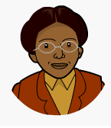
Rosa Parks

