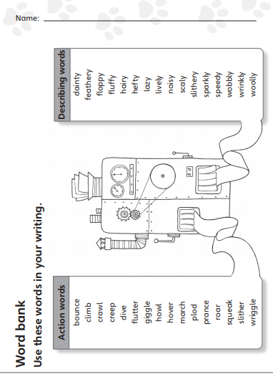

**Wordbank**

Use the words to help you when you write your own ‘Imagine If’ poem.