Lost and Found Reading Comprehension

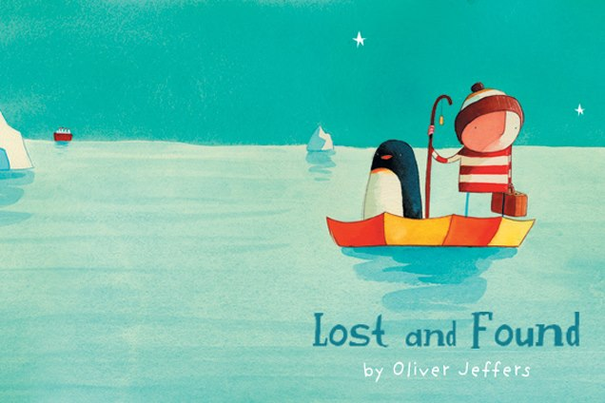
- How do you think the penguin got to the little boy’s house in the first place?

- Why couldn’t the people on the ship hear the little boy?

- What mistake did the little boy make?

- Why is it funny when it says ‘some birds are just like that’?

- How do you think the boy and the penguin felt whilst they were rowing, during the bad weather?

- How do you think the little boy felt, when he realised his mistake?

- Why did the little boy take the penguin to the Lost and Found Office?

- What did the penguin and the little boy test the boat for?

- When he rowed back, why couldn’t he find the penguin?

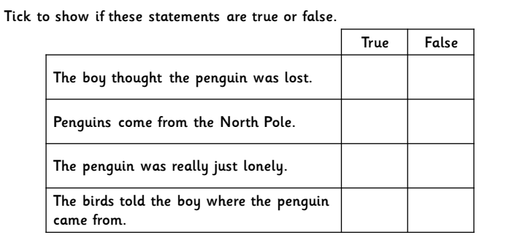
- What do you think happened when they got back home?

