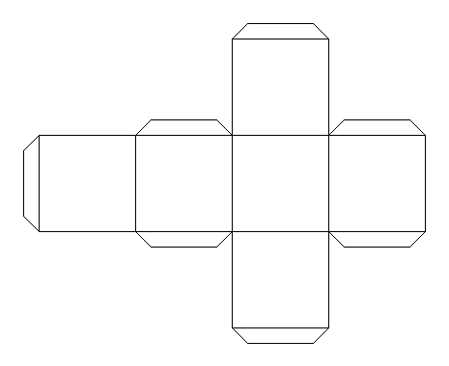
Year 3 RE Lesson W/B: 4.5.2020 Aspects of Me
Learning Objective: We are learning to understand the Hindu belief that there is one God with many different aspects.
Think about who are you and what you mean to different people?
Using the net of the cube above either draw yourself or stick your photograph onto each side. Label it with the different ways people see you, for example you may be a daughter, sister, friend, Brownie, pupil, granddaughter etc.
Cut out and put the net together to show the different sides you have.
What is it that stays the same on each side?
Remember whilst you may be different things to different people there is only one of you. You are still yourself and all the sides are part of the same YOU.
What is it about you that is inside the box that makes you you?
If possible keep the net of the box as we will refer back to it as part of the next lesson.
If you do not wish to use the net of the box you can still complete the same activity by creating a list and drawing yourself next to each label. Alternatively you may think of your own creative way to display the information.

