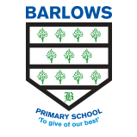
Barlows Primary School
Home Learning Comprehension questions

Year Group: | Year 4 | Teachers: | Miss Mills-Baines  Miss Long
Week Commencing: | 04/05/20

Reading comprehension questions

Please Mrs Butler-
- Find and copy two examples of rhyming words within the poem.
- Who is speaking in the poem? How do you know this?
- Do you think that Mrs Butler is helpful in the poem? Give one example from the text to explain your answer.

Excuses Excuses-
- Find and copy an example of alliteration within the poem.
- Is it the same child with lots of excuses or different children speaking? Why do you think this?

