- Find a cube that is used to play a game.
- Name a cuboid that a fish can live in.
- Find a sphere you can bounce.
- Name a cone you can wear on your head.
- Find a cylinder in your kitchen.
- Name a cone that you can eat ice cream in.
- Find a cube made from cardboard.
- Name a sweet that is the shape of a sphere.
- Find a cuboid in your living room.
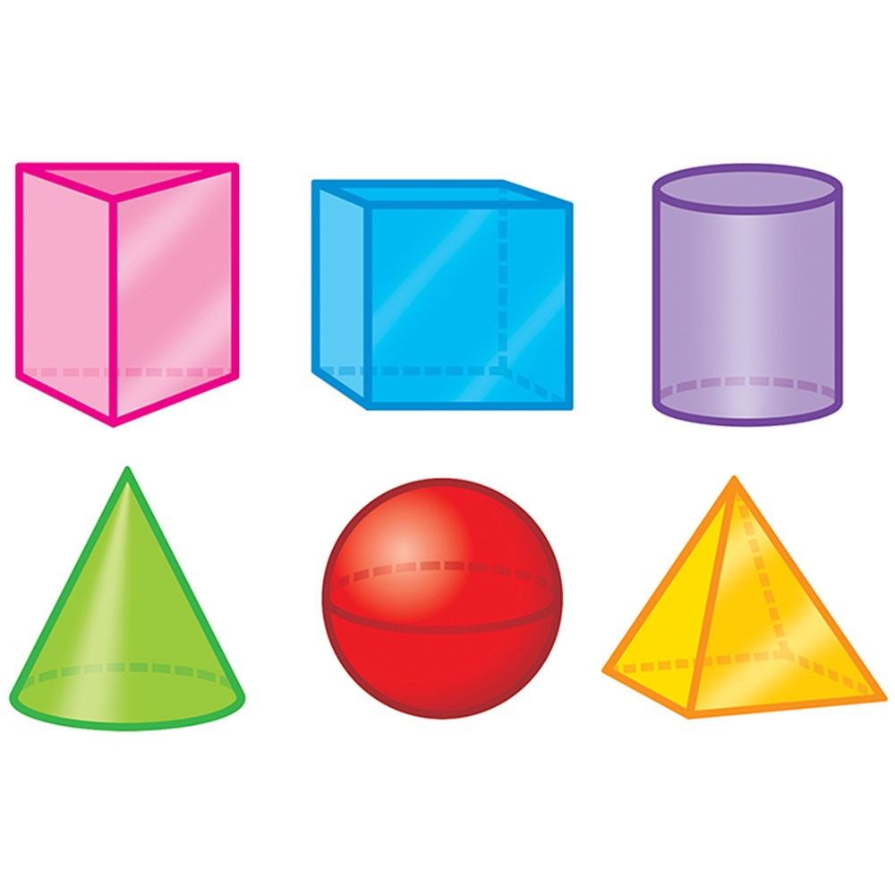
- Name a cylinder in the bathroom.

