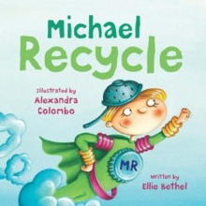

Reading Comprehension
Talk about your answers with a grown up
or you could write your answers below.

- What is the problem in the town of Aberdoo-Rimy?
__________________________________________________________________________________________

- How did Michael Recycle describe the town’s sky and river?
______________________________________________________

- What did Michael tell the town’s people to do?
______________________________________________________

- What words does the author use to describe the town at the end of the story?
______________________________________________________

Reading Comprehension -ANSWERS
Talk about your answers with a grown up
or you could write your answers below.

- What is the problem in the town of Abberdoo-Rimey?
The garbage (rubbish) was left to go rotten and slimy.

- How did Michael Recycle describe the town’s sky and river?
The sky and the river were smelly and brown.

- What did Michael tell the town’s people to do?
Michael said you’ve got to recycle.

- What words does the author use to describe the town at the end of the story?
The town was clean and brand new. It gleamed and glittered.

