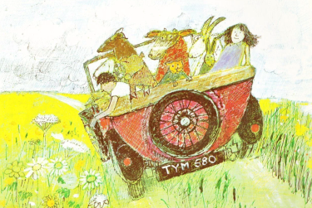
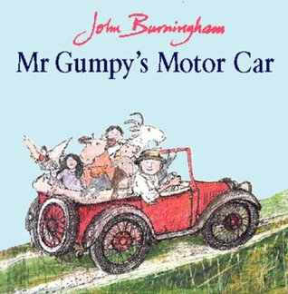
Mr Gumpy’s Motor Car-
Comprehension

- What colour was Mr Gumpy’s car?
_______________________________________
- Why did Mr Gumpy not like the clouds?
_______________________________________
- Why did the rabbit say he couldn’t help?
_______________________________________
- What word means the same as pushed?
_______________________________________
- Do you think Mr Gumpy’s car is modern or old fashioned? Why?
_________________________________________________________________________________________________________

Mr Gumpy’s Motor Car-
Comprehension- ANSWERS

- What colour was Mr Gumpy’s car?
Mr Gumpy’s car was red.
- Why did Mr Gumpy not like the clouds?
He thought it was going to rain.
- Why did the rabbit say he couldn’t help?
He wasn’t very well.
- What word means the same as pushed?
Shoved means the same as pushed.
- Do you think Mr Gumpy’s car is modern or old fashioned? Why?
I think it is an old-fashioned car because the wheels are very thin and it doesn’t have a roof.
(plus other optional answers)

