Story Map Example and character cut outs if required

[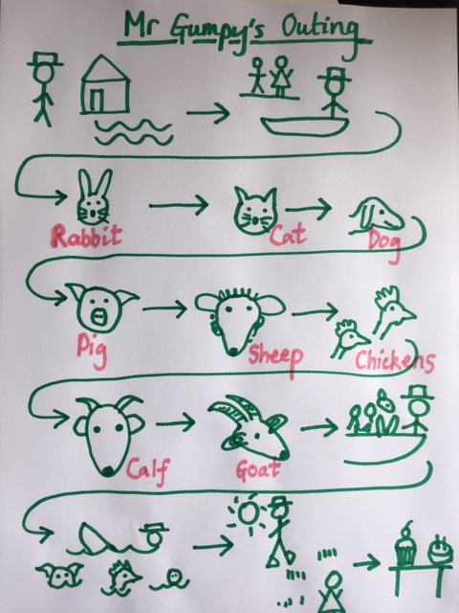](https://www.google.com/url?sa=i&url=https%3A%2F%2Fwww.mayflower.towerhamlets.sch.uk%2Ftag-cloud%3Fhashtag%3Dstorytelling&psig=AOvVaw1Rvm33hHwHlJK_eg8vJI2J&ust=1593803656722000&source=images&cd=vfe&ved=0CAIQjRxqFwoTCMjRgb2jr-oCFQAAAAAdAAAAABAE)

