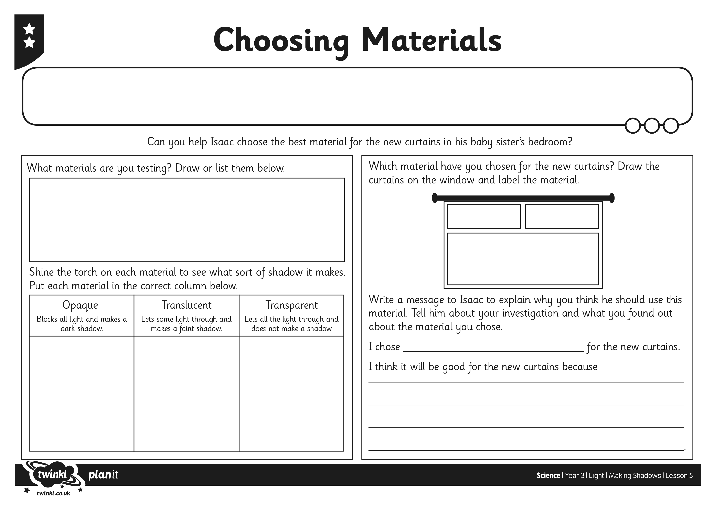

Work through the PowerPoint presentation to learn more about shadows before you complete this activity.

(See Year 3 Science PowerPoint in the Y3 Home Learning Section wc 13 07 20)

Insert text here.