**Barlows Primary School Uniform**

At Barlows Primary School, we see school uniform as an essential part of school life. Wearing school uniform provides a sense of belonging and sets the appropriate tone for education. It unites all children in our school. We appreciate that uniform can be expensive and therefore offer the option of wearing uniform with or without the school logo, to support families in purchasing cost effective options.

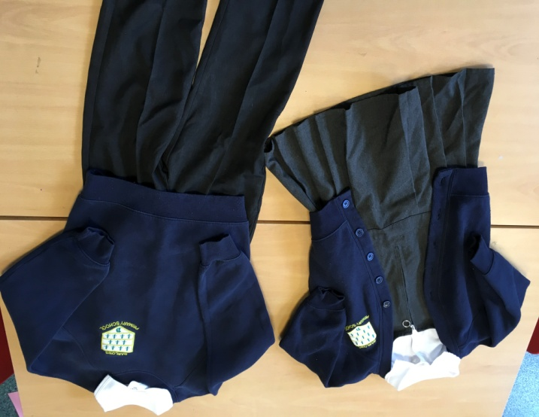**School Uniform**

* Top - White polo shirt (plain or with optional Barlows logo)
* Navy blue cardigan or jumper (plain or with optional Barlows logo)
* Grey trousers / shorts / skirt / pinafore
* Socks – plain black, grey or white socks or plain black / grey tights
* Shoes – plain black school shoes or plain black trainer style shoes without motifs/logos. Converse style shoes and jelly shoes are not part of the school uniform.
* Summer dresses – summer school dresses in blue/navy gingham are allowed in the summer term.

**PE Kit**

On the day that your child has PE, please send them into school already wearing their PE kit. They will remain in their PE kit for the duration of the day. The PE Kit for Barlows is as follows:

* Navy blue Barlows school jumper or cardigan
* Plain white T-shirt (plain or with optional Barlows logo)
* Plain navy blue jogging bottoms and/or navy blue shorts (plain or with optional Barlows logo)
* Trainers suitable for sports activities.
* **Not permitted** - Football kits, gym leggings, gym tops, hoodies, tracksuit tops or other branded/non branded clothing are not permitted.

All clothes should be plain and free from large brand logos to avoid brand competition and peer pressure amongst children.

**Jewellery, Watches, Bags, Water Bottles and Hair Accessories**

* Earrings - Stud earrings are allowed (any other type of earrings should not be worn)
* Jewellery – – Jewellery including necklaces, rings and any type of bracelet or bangle are not permitted, with the exception stud earrings
* Smart watches are not allowed for pupils, for safeguarding reasons. This includes any watch with a camera, recording (voice or video) or that connects to Wi-Fi/a mobile phone.
* Hair accessories – hair accessories (bobbles, simple headbands, slides etc.) should be black, navy or white. They should be comfortable and not cause distraction.
* Bags and pencil cases – as space is limited bags are not permitted with the exception of Barlows book bags or small navy drawstring bags. These can be purchased from a supplier below (these are optional). Rucksacks and handbags are not permitted. We provide a transparent plastic book bag at the start of each academic year for all pupils at no cost. Pencil cases are not permitted. School will provide the necessary station for pupils.
* Water bottles – the school will provide each child with a school water bottle which will remain in school. Personal water bottles are not permitted for use in the classroom.

School uniform can be purchased from a number of locations including:

|  |  |  |
| --- | --- | --- |
| LiverPrint, 26 St Chad's Drive,  Kirkby, Liverpool, L32 8RH | Kids Kirkby, 29 St. Chads Parade, Kirkby, L32 8UG | Online at:[www.yourschooluniform.com/](http://www.yourschooluniform.com/)  Many local supermarkets |

**Preloved Uniform**

If you are looking for a more sustainable eco-friendly solution, we have many preloved items of uniform available via our school office – please do not hesitate to get in touch, we would love to see them go to a good home!

Our expectations for school uniform are non-gender specific. Our pupils have the choice of what uniform they want to wear from the list provided above and all uniform is available to people of all genders. We also appreciate that some religions require specific items to be worn.

If you are unsure or have any questions, please do not hesitate contact us, we are always here to help!